**PF Lab No: 03**

**Name: Ali Rooman**

**Roll No: 24K-0792 (BCS-1J)**

Q1:

Ans.

|  |
| --- |
| #include <stdio.h>  int main() {  float vi, a, t, vf;  printf("Enter initial velocity (vi): ");  scanf("%f", &vi);    printf("Enter acceleration (a): ");  scanf("%f", &a);    printf("Enter time (t): ");  scanf("%f", &t);  vf = vi + a * t;  printf("The final velocity (vf) is: %.2f\n", vf);  return 0;  } |

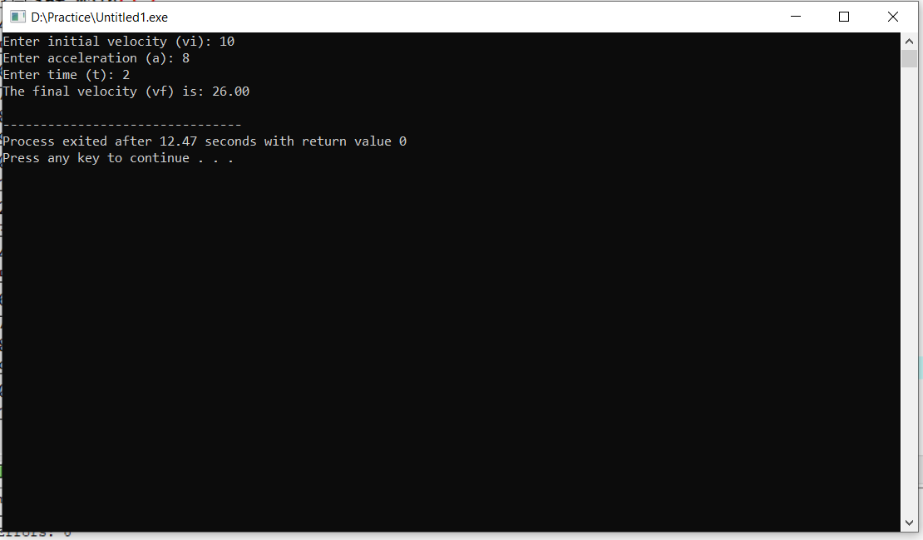**Output of code:**

Q2:

Ans.

|  |
| --- |
| #include <stdio.h>  int main() {  float vi, a, t, vf;  printf("Enter initial velocity (vi): ");  scanf("%f", &vi);    printf("Enter final velocity (vf): ");  scanf("%f", &vf);    printf("Enter time (t): ");  scanf("%f", &t);  a = (vf - vi)/t;  printf("The acceleration (a) is: %.2f\n", a);  return 0;  } |

**Output of code:**

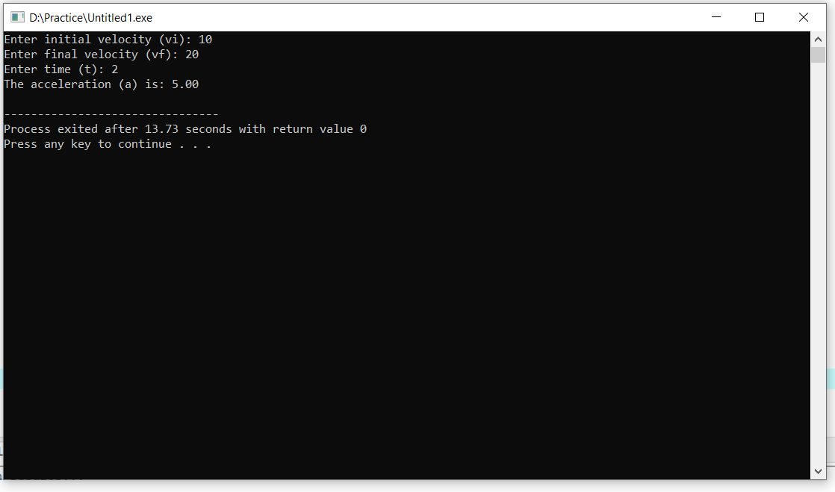

Q3:

Ans.

|  |
| --- |
| #include <stdio.h>  int main() {  float salary, taxRate, taxAmount, netSalary;  printf("Enter your salary: ");  scanf("%f", &salary);  printf("Enter tax rate (as percentage, e.g., 10 for 10%%): ");  scanf("%f", &taxRate);  taxAmount = salary * (taxRate / 100);  netSalary = salary - taxAmount;  printf("The tax you have to pay is: %.2f\n", taxAmount);  printf("Your salary after paying tax is: %.2f\n", netSalary);  return 0;  } |

**Output of code:**

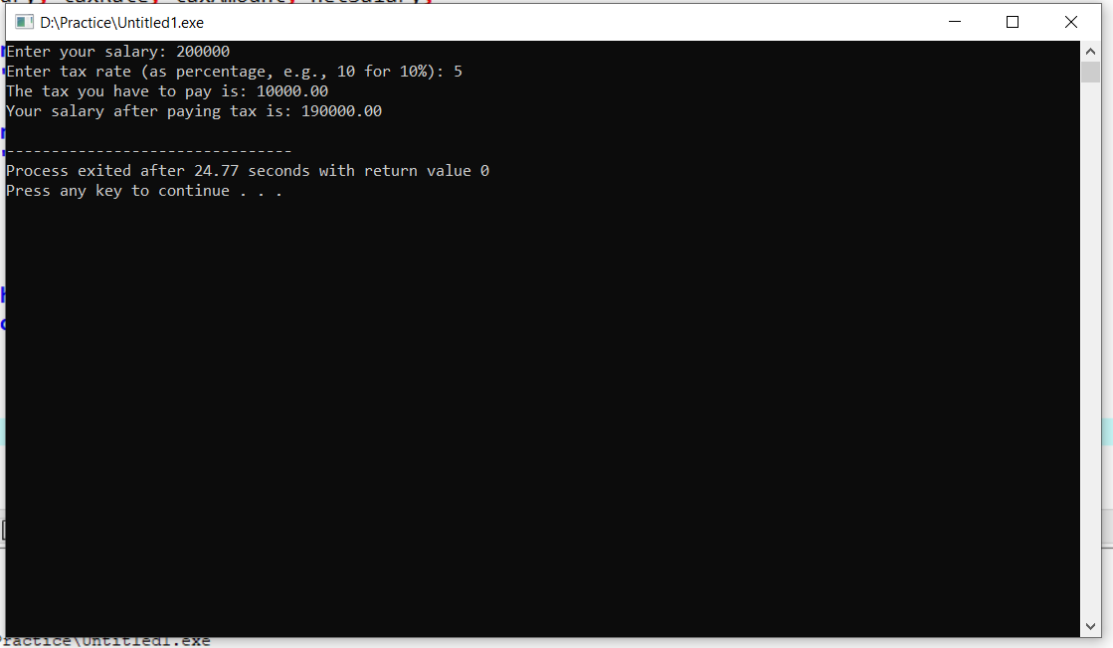

Q4:

Ans.

|  |
| --- |
| #include <stdio.h>  int main() {  float x1, y1, x2, y2 , m;  // you can use scanf function to get input from user but in question points are already given  x1 = 5;  y1 = 4;  x2 = 3;  y2 = 2;    // Formula for Slope  m = (y2-y1)/(x2-x1);    printf("The slope between points (5,4) and (3,2) is: %.3f \n", m);  return 0;  } |

**Output of code:**

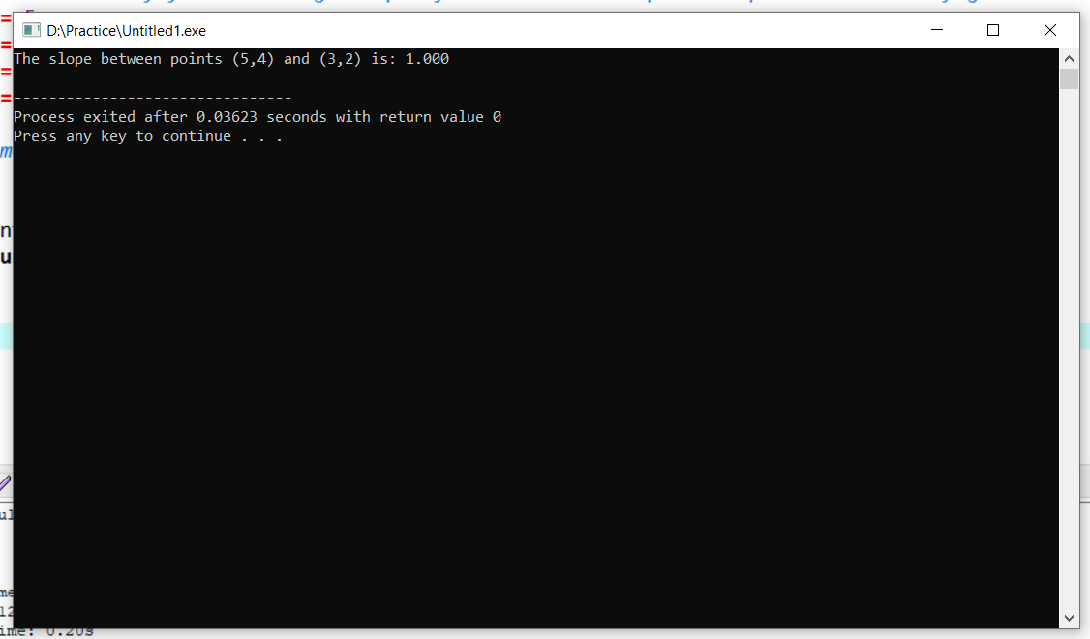

Q5:

Ans.

|  |
| --- |
| #include <stdio.h>  #include <math.h>  int main() {  float P,N,R;  double CI;  printf("Enter the value of Principal (P): ");  scanf("%f", &P);  printf("Enter number of years (N): ");  scanf("%f", &N);  printf("Enter Rate of interest: ");  scanf("%f", &R);  CI = P * (pow(1 + R/100,N)) - P;    printf("The Compound interest according to your input is: %lf \n", CI);  return 0;  } |

**Output of code:**

